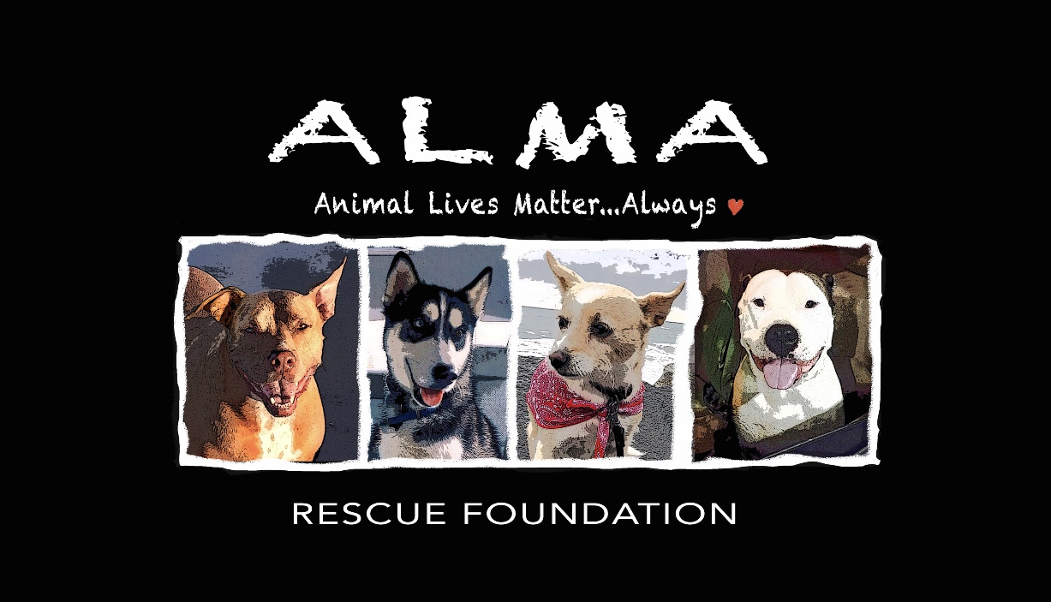
PET ADOPTION CONTRACT
Please read this carefully. This is a legally binding document.
CURRENT OWNERS (1) NAME: ALMA RESCUE
ADDRESS: 1845 Downs Street CITY: Oceanside ZIP CODE: 92054
PHONE: 760-458-9588
ADOPTED ANIMAL’S NAME:
BREED: SEX: Spayed/Neutered: AGE:
I. _______________________________________, hereby referred to as the adopter (2) agree that the above described dog is being adopted by me solely as a pet for myself and/or my immediate family. I agree that I will not sell, give away or otherwise dispose of said dog to any person(s), dealer, retailer, auction, institute or any other entity for any reason. If at a later date I am unable or unwilling to keep this pet, I agree to first contact the above described current owner (ALMA Rescue) and give them the option to reclaim said pet at no charge. I also understand that if any breeches of this contract should arise, ALMA Rescue has the right to take back our rescued pup. _____ Int
I hereby agree to care for the above described dog and promise it will be treated like a family member with loving care and affection. I will do my best to ensure the dog’s safety and well being. I will provide my new pet with clean and adequate shelter, food (feed twice a day,) water, exercise and veterinary care. I will walk my dog on a leash or exercise my dog in a fenced area. I will never let my dog run loose or roam, keep my dog chained or tied up, keep it continuously in a yard, garage, patio, balcony, or pen, or leave my dog outdoors, even in a fenced yard when no one is at home. I will not crate my pet for more than 3-4 hours. _______ Int

I will ensure proper licensing of the dog and will attach the appropriate license tags, rabies tag, AFH tag, and personal identification tag to a non-choke collar to be worn at all times. I will ensure compliance with all applicable local and state statutes. _______Int
I hereby agree to pay the Adoption Fee of $250 for pups/dogs 5 months or older and $500.00 for puppies under 5 months and understand that this Adoption Fee helps cover all of ALMA’s medical/veterinarian expenses including: initial pet exam, all vaccinations & immunizations appropriate with dog’s age, fecal exams, de-worming, all medications, treatment for flea/tick prevention, micro-chipping & spaying/neutering surgeries. Our Adoption Fee also covers all food
and costs of caring for our pups, sometimes from birth, as well as gas for transporting animal if coming from Baja, Mexico or another city or state.
This fee must be paid at the time of adoption in Cash, through Venmo or through our PayPal account. This adoption fee is not refundable for any reason. ________ Int
(*Cancelled due to Covid!) I understand that ALMA will need to do a home inspection before adoption is finalized. I/we affirm that no member of my household has been convicted of an animal welfare law violation such as neglect, cruelty, abandonment etc. N/A Int
I give ALMA Rescue permission to use me and my pup’s photos (adoption day and any other photos I share with Alma in the future) on their Social Media Platforms _____ Int
I hereby understand and agree that the current owner (ALMA) makes no representations or warranties, expressed or implied, about the above mentioned animal's temperament and medical condition and is hereby absolved from any liability for future damages or injuries caused by said animal. I understand that ALMA can only guess at the “breed/mix” of the dog I am adopting and that the current owner (ALMA) further gives no guarantees, expressed or implied, of the suitability of the animal to the adopter and/or his family. I agree to accept responsibility and ownership of the dog at my own risk and I release ALMA Rescue and its agents from any and all liability arising out of possession and ownership of my dog. I agree that I am assuming total financial responsibility for my pet as of the date of this contract. ALMA Rescue and its agents will not be held responsible for any damages or expenses (veterinary or other) incurred during my ownership of the dog. _______ Int
ADOPTER'S NAME _______________________________________________________
ADDRESS: _____________________________________ CITY ______________________________ ZIP CODE ____________
PHONE ___________________________ E-MAIL: _____________________________________________________
EMPLOYER: _____________________________________________ POSITION: _________________________________
PHONE NUMBER: ______________________________________
I certify that all statements made by me on this adoption agreement are true and correct. I agree that the current owner has the right to confiscate the above described animal in the event that any statements made by me are found to be false.

ADOPTER’S SIGNATURE ________________________________________________DATE: _______________
ALMA WITNESS SIGNATURE ___________________________________________DATE: _______________
INSTAGRAM USERNAME _______________________________________________________________________*We love following our rescue pup’s journey, so please tag us when you post their picture!
1 Current owner is defined here as the person who originally held the above described animal in their possession. 2 Adopter is defined here as the person who accepts for adoption the above described animal.

TIME SENSITIVE

ALMA Rescue requires that all Adopters obtain a Dog License within the first 30 days after adoption.

California state law requires that all dogs be vaccinated against rabies (which Alma Rescue has already taken care of) and licensed through the local San Diego Humane Society.
ALMA Rescue requires that your dog obtain their license within 30 days of adoption.

California Health and Safety Code (121690) requires all dogs to obtain a license:
- Within 30 days of acquiring the dog, or
- Within 30 days after entering the jurisdiction.
- If your dog is ever missing, a license tag provides a quick and accurate way of notifying you if someone else finds your pet. It also provides proof that your dog has been vaccinated against rabies, as required by law.
Once your dog has been assigned a license, the number and the information about your dog is permanently filed in the San Diego Humane Society’s records. Your dog keeps the same license tag number for life. You can easily obtain your dog’s license online at: PetHub.com
I agree to take my dog to a licensed veterinarian when shots are due, no later than one year from the last vet visit. I will provide all required and/or needed veterinary care, including: rabies shots as required every one or three years; yearly booster shots for DHLPPC; yearly veterinary check up and prompt treatment by a licensed veterinarian for any illness or injury. I hereby agree that within 30 days of adopting my dog, I shall get her/him licensed through the HSUS. I agree that I will make sure my dog wears a collar with personalized identification tags at all times. ALMA requires proof of license per state law. Please email a screenshot of license numbers to Alma Rescue Founder Erin at: erin@almarescuefoundation.com so we can put in your dog’s file. __________ Int
Date: __________________ Signature: ____________________________________________________________
_________________________________________________________________________________________________________________________
MICROCHIPS

Alma Rescue microchips all of our pups. We will be the main contact should your dog get out and be taken to a vet or the shelter to be scanned, our phone number will be the first they call.

Please fill out the Microchip brochure enclosed with your name and information so that your name and phone number is also listed on the account. Please attach the blue Microchip tag to your dog’s collar.

